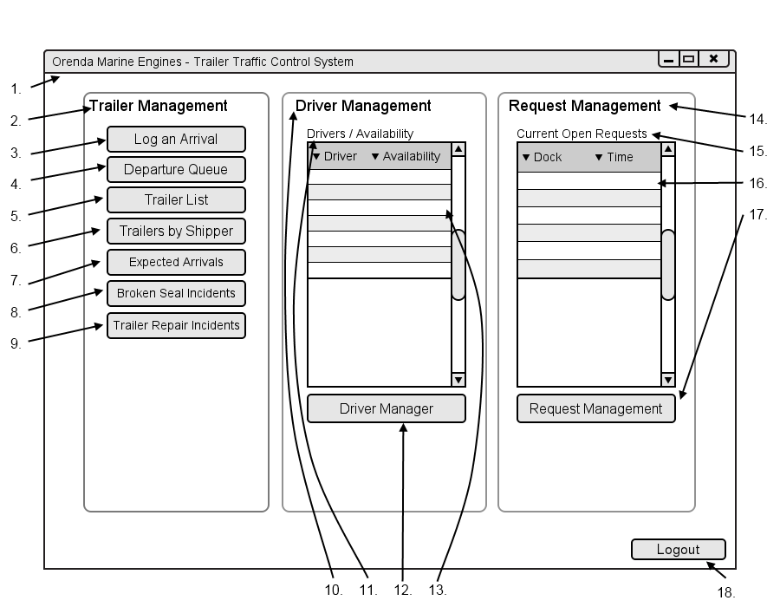

|  |  |  |  |
| --- | --- | --- | --- |
| # | Type | Text | Functions/Notes |
| 1 | Windows | Orenda Marine Engines – Trailer Traffic Control System | 800x600 |
| 2 | Label | Trailer Management |  |
| 3 | Button | Log An Arrival | Displays the Bill of Lading Dialog |
| 4 | Button | Departure Queue | Displays the Departure Queue Dialog |
| 5 | Button | Trailer List | Displays the Trailer List Screen |
| 6 | Button | Trailer By Shipper | Displays the Trailer By Shipper Filter Dialog |
| 7 | Button | Expected Arrivals | Displays the Expected Arrivals Screen |
| 8 | Button | Broken Seal Incidents | Displays the Broken Seal Incidents Screen |
| 9 | Button | Trailer Repair Incidents | Displays the Trailer Repair Incidents Screen |
| 10 | Label | Driver Management |  |
| 11 | Label | Drivers/Availability |  |
| 12 | DataGrid |  | Fields : Driver Name, Current Availability  This displays a list of all current drivers and their current status : Off Duty, Available, On Task |
| 13 | Button | Driver Manager | Displays the Driver Manager Screen |
| 14 | Label | Request Management |  |
| 15 | Label | Current Open Requests |  |
| 16 | DataGrid |  | Fields : Dock, Time  This displays a list of all requests that need the dispatchers’ attention.  They are sorted by Time from soonest to latest. Plant are highlighted light green, warehouse are highlighted light blue.  Requests with an issue are placed at the top highlighted red. |
| 17 | Button | Request Management | Displays the Request Management Screen |
| 18 | Button | Logout | Logs the Dispatcher out of the system |